Investigator EK60 processing for IMOS

|  |  |
| --- | --- |
| **Version:** | 3.0 |
| **Last edited by:** | Amy Nau |
| **Date:** | 25 Feb 2020 |
| **Software version:** | Echoview 10.0.293  Matlab R2019b |



Contents

1 Introduction 4

1.1 Notes on software versions 4

2 Copying data and Pre-processing 4

2.1 Copying raw data 4

2.2 Identify transects using BASOOP.jar 5

2.2.1 Register data for entire voyage 5

2.2.2 View INF file to determine transect start/end 7

2.2.3 Setting up the raw data folders 9

3 startBASOOP- Matlab GUI 12

3.1 Starting the GUI 12

3.1.1 Step 1: Creating new EV files 13

3.1.2 Step 2: Review EV worksheets 16

3.1.3 Step 3: Export echo-integration 17

3.1.4 Step 4: Packaging into NetCDF, metadata and visualisation 18

4 Echoview Processing 25

4.1.1 Echoview overview of things to check 25

4.1.2 Echoview helpful hotkeys 25

4.1.3 Navigating the dataflow 25

4.1.4 Regions 26

4.1.5 Acoustic bottom 27

4.1.6 Lower line 27

**Figures**

Figure 1. BASOOP.jar main interface. 5

Figure 2. Registration of raw EK60 data files- creation of *.inf files. 6

Figure 3. Processing bar for data registration 6

Figure 4. Example of *.inf file showing data acquisition settings used. 7

Figure 5. Browse to the folder. 8

Figure 6. Voyage track from INF files. 8

Figure 7. Example of designating transects along a voyage track. Red lines are individual transects to be processed. 9

Figure 8. View > Generate echoview *.csv files. 10

Figure 9. Example of how to name GPS.CSV file within raw data folder. 10

Figure 10. Progress bar for generating gps.csv files. 11

Figure 11. Initial Matlab view for startBASOOP GUI. 12

Figure 12. GUI start-up parameters. 13

Figure 13. GUI default interface. 13

Figure 14. Red arrows indicate fields that must be filled in for initial creation of EV files. 14

Figure 15. EV file creation confirmation. 15

Figure 16. UTC time offset check window. 15

Figure 17. File structure created from GUI. 16

Figure 18. Review Echoview worksheets step. 16

Figure 19. Review Echoview worksheets window. 17

Figure 20. Echo-integration output created. 18

Figure 21. GUI boxes to be checked for final packaging. 19

Figure 22. Initial metadata warnings. 19

Figure 23. Pre-metadata box 20

Figure 24. Review metadata- global attributes. 21

Figure 25. Review metadata- frequency specific. 22

Figure 26. Echoview Ascii export 22

Figure 27. Metadata compliance check message box. 23

Figure 28. Visualise NetCDF. 23

Figure 29. Final NetCDF file location. 24

Figure 30. Echoview Dataflow and processing setup. 26

Figure 31. Tool options for creating polygons. 26

Figure 32. Region Browser window- make sure to change these values each time a region is created. 27

Investigator EK60 processing for IMOS

# Introduction

This document describes the processing procedures used for processing EK60 data acquired by RV Investigator. The data are processed using the Matlab GUI (developed by the bioacoustics team at CSIRO), Echoview, with a final NetCDF that can be posted to IMOS under the Bioacoustics program.

## Notes on software versions

Currently, Echoview 10 is used for this processing, but this can change with the new release of Echoview.

The current Investigator template is:

Q:\IMOS_echoview_templates\IMOS_BASOOP_template_Ex60\Ex60_V1.28.ev.

The following path must be mapped as the Q: drive. This path is predefined the Matlab GUI developed by Gordon Keith, so all processing must be done relative to this path (but this can be modified in the default settings code ‘basoop.m’ for third-party usage).

Q: \\oa-ba-soop-work.dataset.csiro.au\ba-soop-work\

The current MATLAB version to use is 2018a, but can change in future with new release.

# Copying data and Pre-processing

There are a few initial steps to copy over and register the data on the Q: drive. These steps help to identify the transects and date ranges of interest, and then organize the data into the appropriate folders to be processed further using the Matlab GUI.

## Copying raw data

The first step is to copy all the raw data from a voyage to the ‘Pending_Registration’ folder on the Q: drive here: Q:\Pending_registration\Year202X\Investigator\. This is a pre-processing step to be able to view the tracks for the entire voyage in Dataview/BASOOP.jar, which can then be used to isolate the specific lines of interest.

The folder should be named ‘voyage_startdate_enddate’. For example, for in2018_v04 which departed on 11/09/2018 and returned 06/10/2018 the folder should be named: ‘in2018_v04_20180911_20181006’. Copy all the files from the EK60 data folder here. This will always need *.RAW files, but may also include *.IDX, *.EVI (created by Echoview, will be recreated if don’t already exist), *.BOT (bottom track from EK60, sometimes useful), *.GPS.CSV, or *.INF.

## Identify transects using BASOOP.jar

BASOOP.jar is a subset version of Dataview. It can be found on the Z: drive here:

Z:\Software\java\dataview\basoop.jar (or can be launched through ‘startBASOOP’ GUI in Matlab (see section 3.1).

This requires JAVA to run. Since JAVA started charging for their program, everyone has migrated over to Amazon Corretto. This will need to be installed before use.

### Register data for entire voyage

When it first opens, click Cancel to the Load Screen window that pops up.

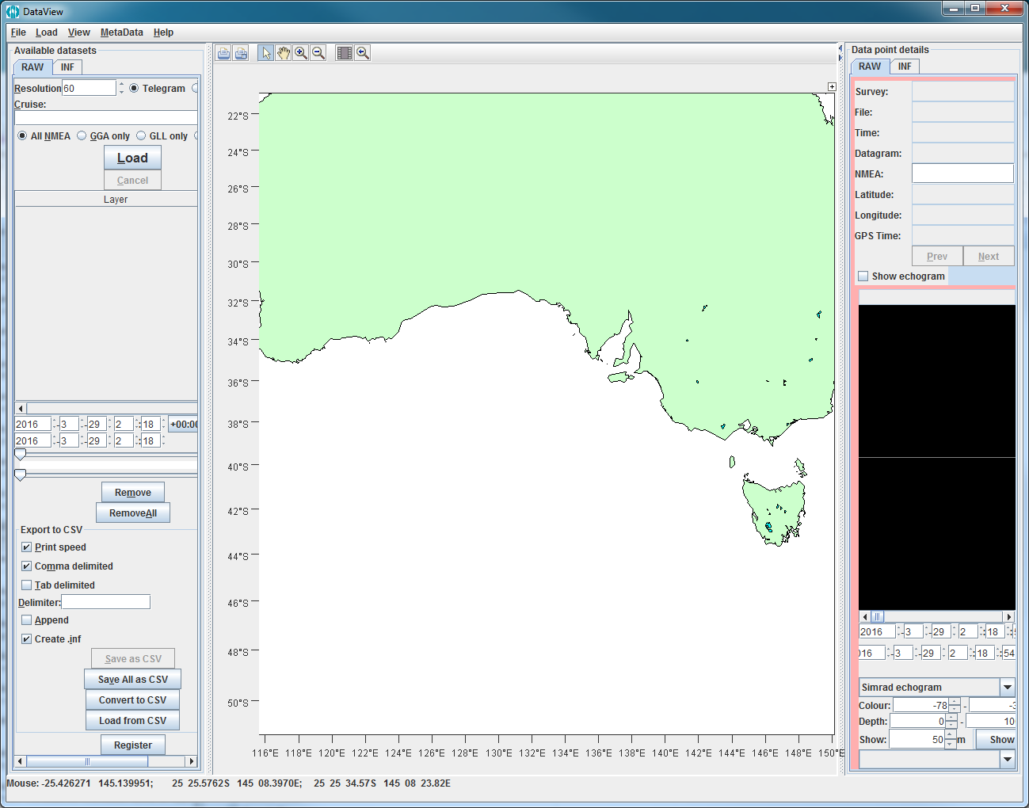

Figure 1. BASOOP.jar main interface.

Click on the RAW tab (left side) and click “Register” at the bottom.

Select “Investigator” from the ship drop down box and type in the voyage name next to Voyage.

Check the box for “Keep statistics”.

Browse to the folder with the raw data files:

E.g. Q:\Pending_registration\Year2019\Investigator\in2018_v04_20180911_20181006

and click “Process”.

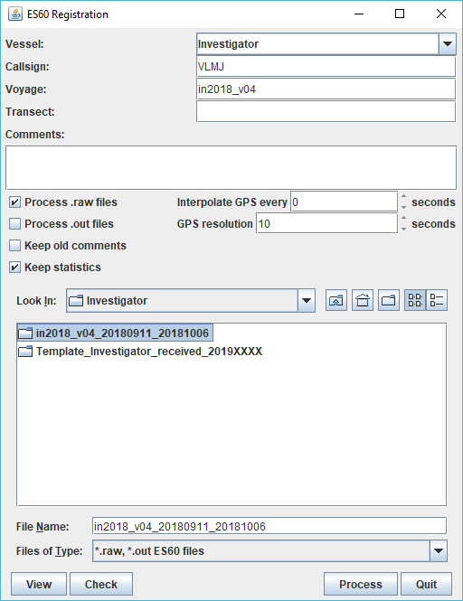

Figure 2. Registration of raw EK60 data files- creation of *.inf files.

This will run through all the raw files and show you a progress bar. Once finished, click “Quit” on the Registration window.

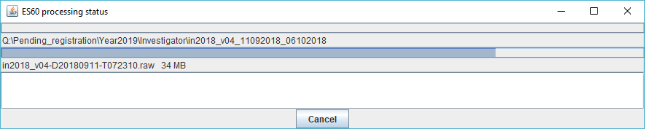

Figure 3. Processing bar for data registration

Once this process has finished, it will have created a *.inf file with the same name as your folder.

### View INF file to determine transect start/end

First, check the INF file created for the whole voyage data. Browse to the *.inf in the base folder here: Q:\Pending_registration\Year2019\Investigator

e.g. in2018_v04_20180911_20181006.inf

Open this file in Notepad (or similar). This will show you a summary of all the settings used for the voyage. Check here that there are only one set of settings, and that they match IMOS settings. If there are multiple different sets, this means you will need to identify which files have IMOS settings and subset them out accordingly.

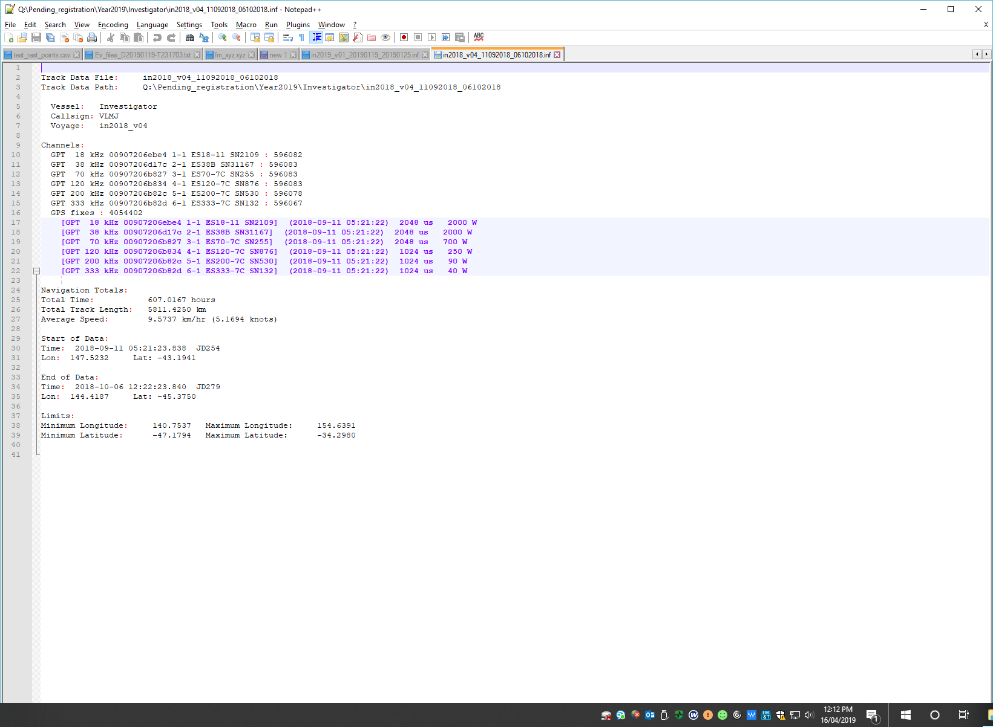

Figure 4. Example of *.inf file showing data acquisition settings used.

Next, load the INFs for the whole voyage in BASOOP.jar. Click on the INF tab on the pane to the left. At the bottom, click “Load”.

Browse to the folder that you just created INF files for and click Open. You should see your voyage track appear on the map.

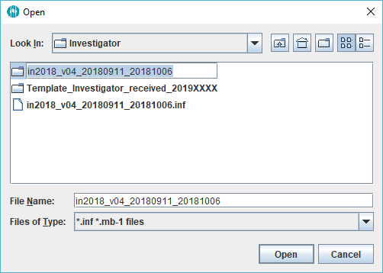

Figure 5. Browse to the folder.

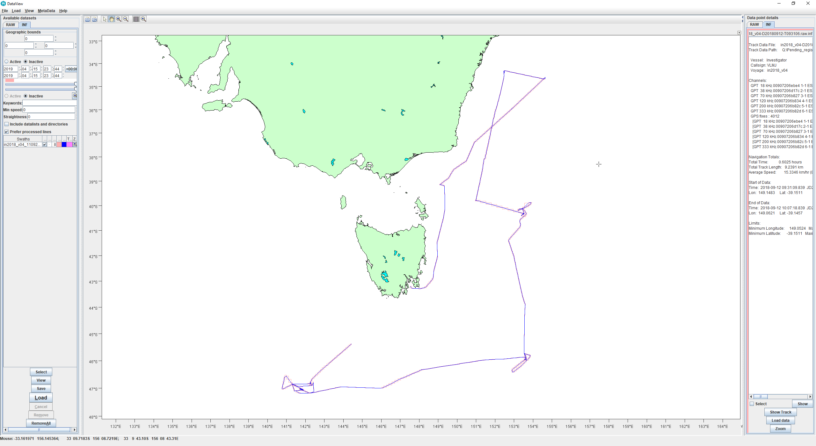

Figure 6. Voyage track from INF files.

Identify the straight segments of interest for processing- generally only long (cross basin) straight segments. For example, for in2018_v04 the following 5 segments were identified (red lines).

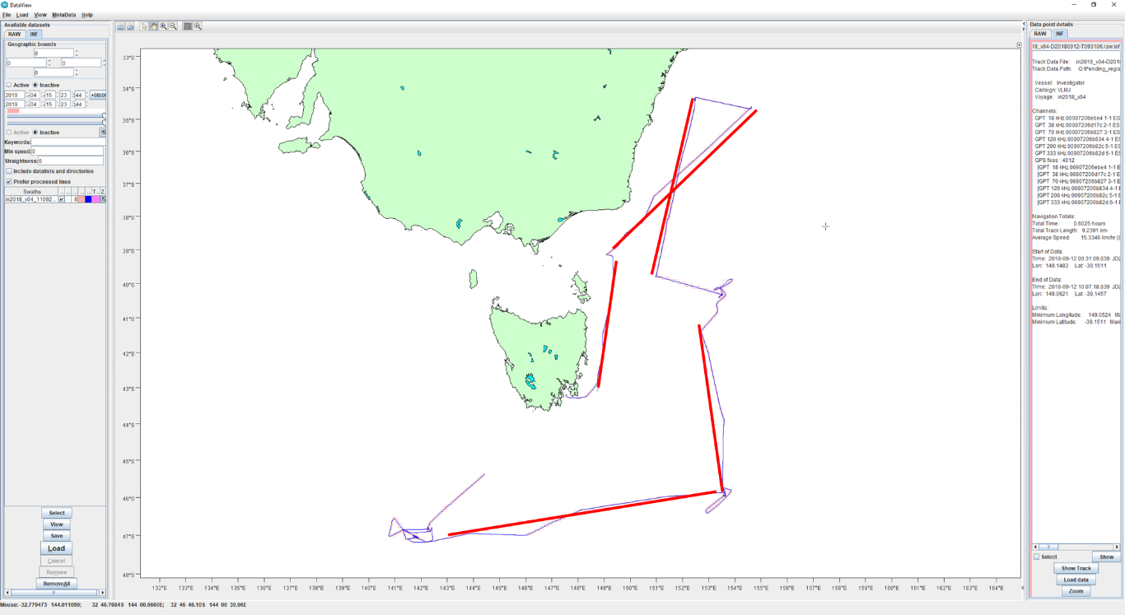

Figure 7. Example of designating transects along a voyage track. Red lines are individual transects to be processed.

Click on the start and end of each segment. On the pane to the right on the INF tab you should see what file this corresponds to. Make a note of the start and end files for each transect.

### Setting up the raw data folders

Once the start/end files for each transect are identified, a new folder for each transect will need to be created in Q:\Rawdata\Investigator.

The folder should be named ‘voyage_transectstartdate_transectenddate’.

For example: in2018_v04_20180922_20180924.

Copy the raw data files that are ONLY within that date/time range of interest from Pending_Registration into the ‘Rawdata’ folder.

Back in Dataview/BASOOP.jar, open the Register dialog again on the Raw tab and browse to the folder with the subset of data you just created. Make sure “Keep statistics” is checked and click Process. This should quickly run through the files (since *.gps.csv are already created from before) and create a general *.INF for the transect in the Investigator directory, for example, “in2018_v04_20180922_20180924.inf”. This can be opened to check the power/pulse settings throughout that section of data.

Go back to the INF tab.

Click “Load” and browse to the folder with the raw data. This will load all data as a single “swath” line. Highlight this line and click “View”. Click “Generate echoview .csv files”.

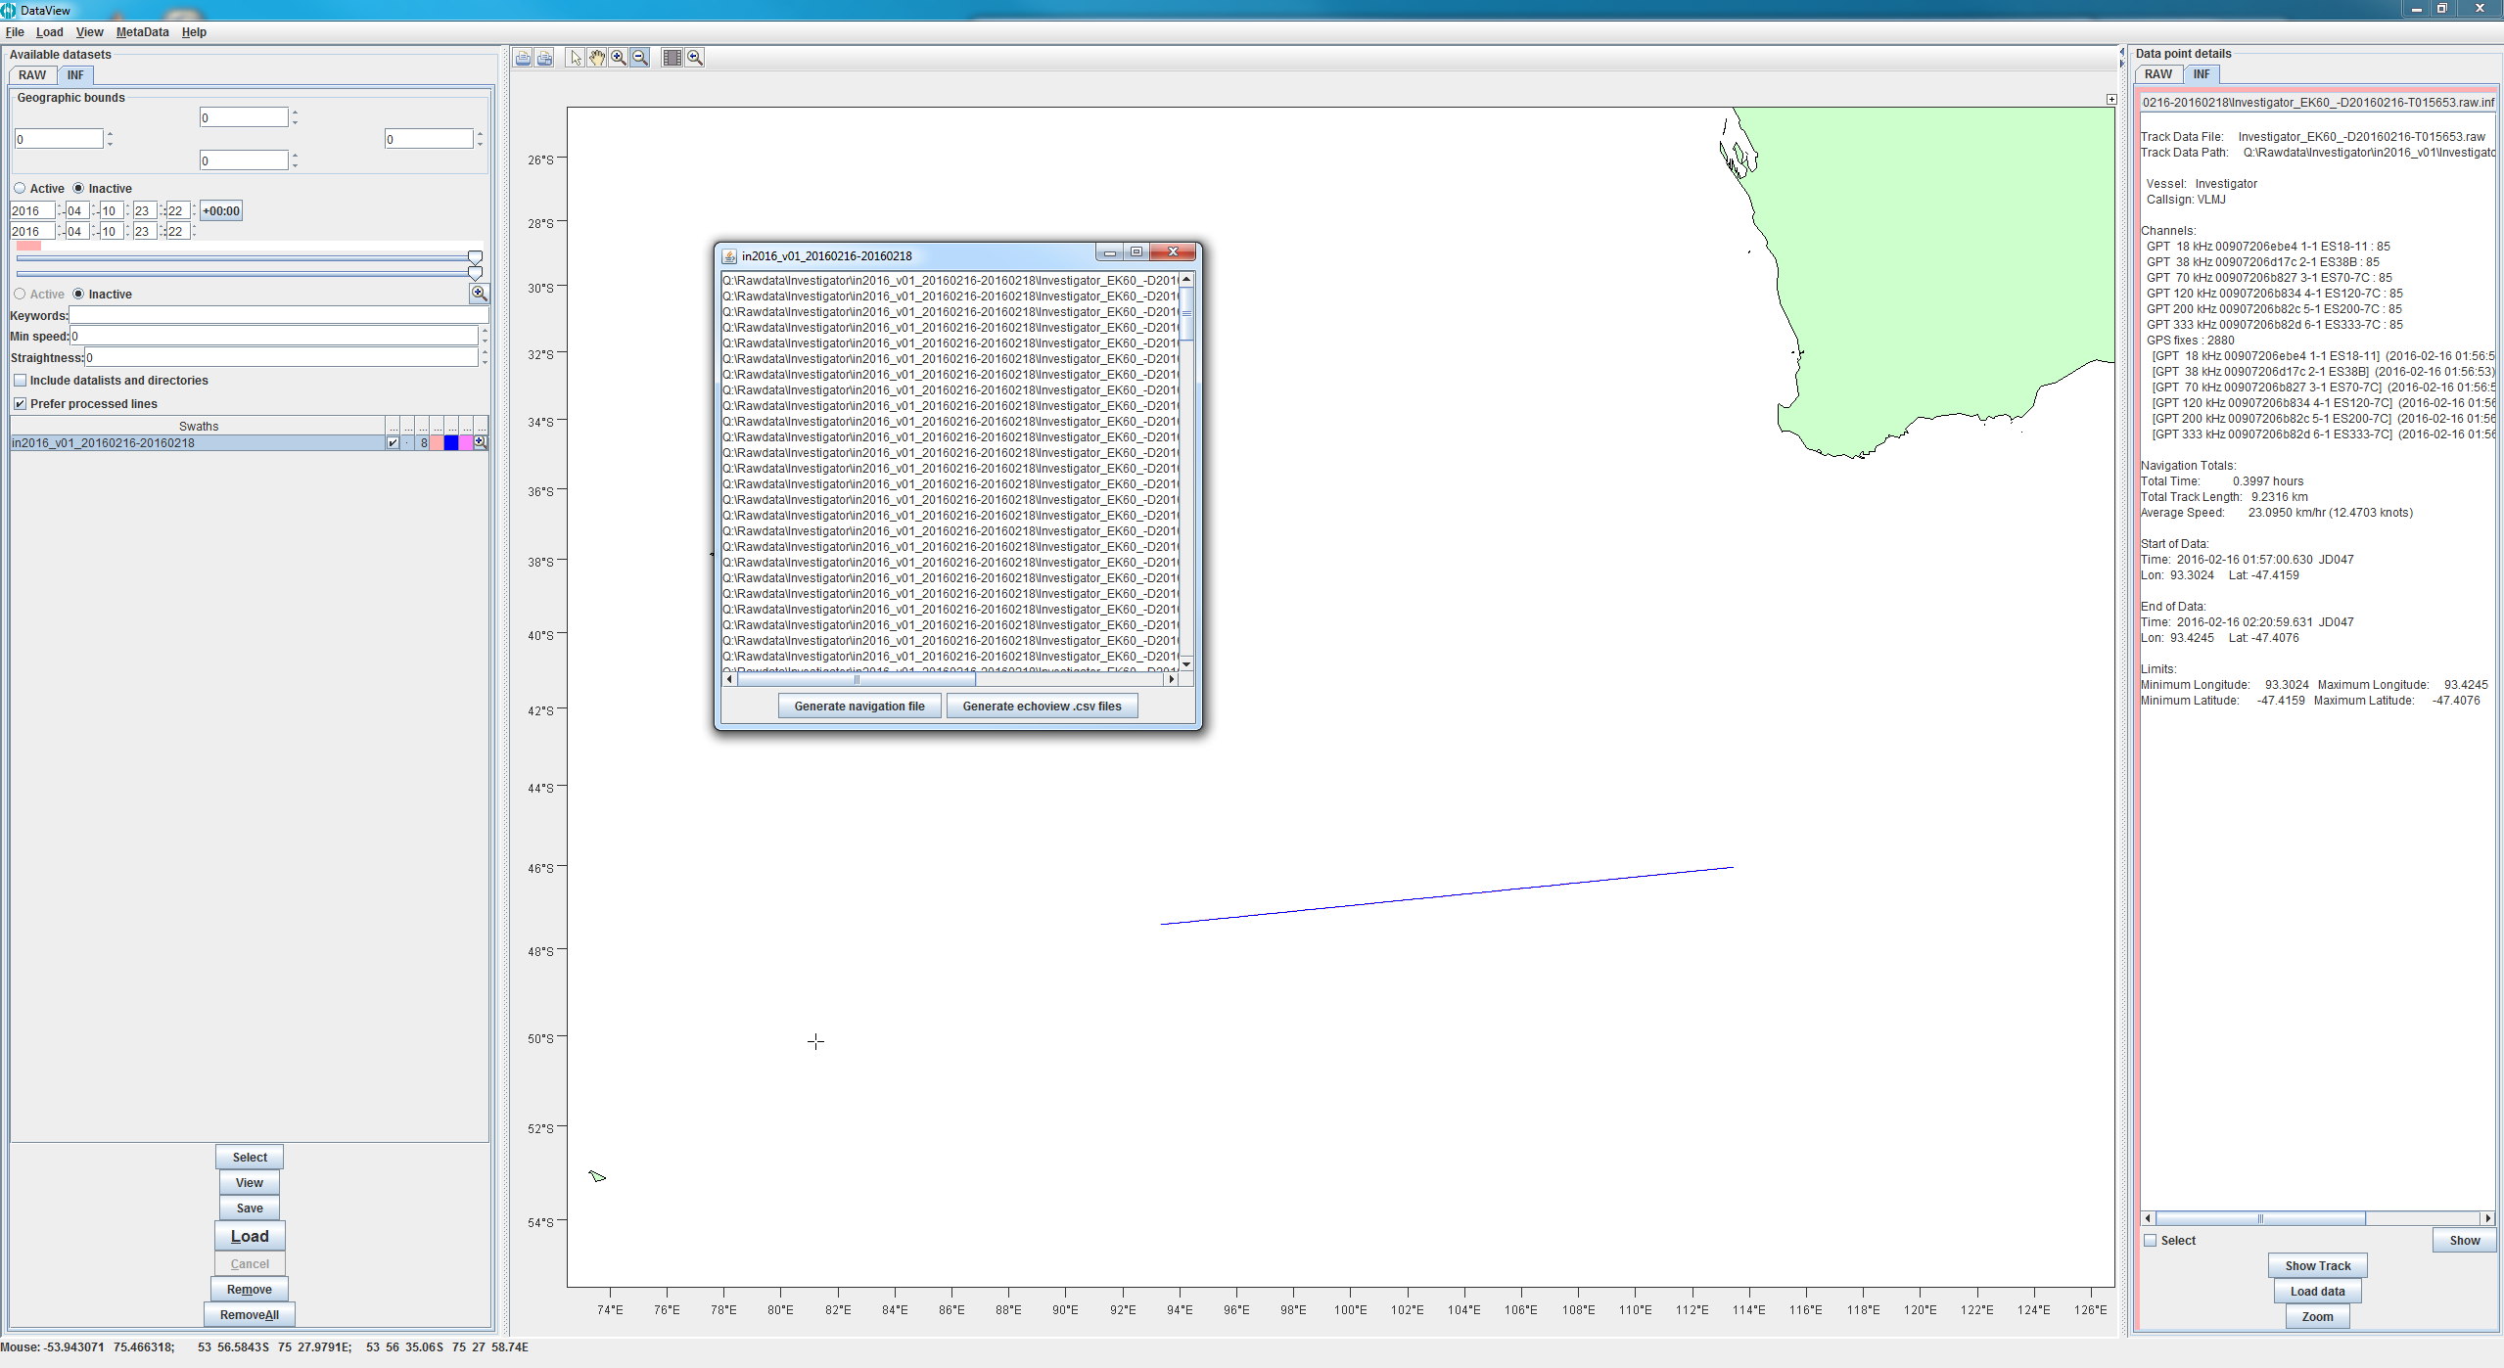

Figure 8. View > Generate echoview *.csv files.

Browse to the subfolder in ‘Rawdata’ folder. Name file with start and end dates as before:

‘in2018_v04_20180922_20180924’.

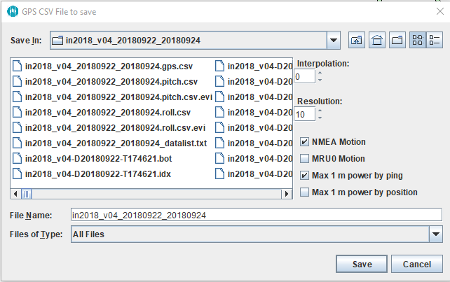

Figure 9. Example of how to name GPS.CSV file within raw data folder.

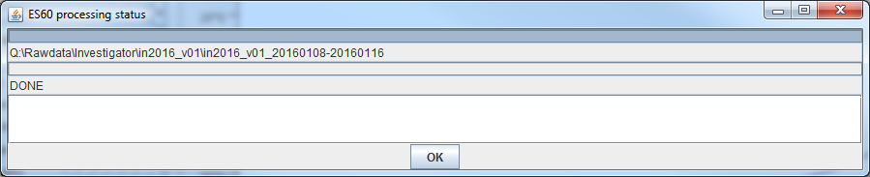

Figure 10. Progress bar for generating gps.csv files.

This will create the following files:

**in2018_v04_20180922_20180924_datalist.txt**: list of raw data files and locations that will be used to create the EV files later.

**in2018_v04_20180922_20180924.gps.csv**: GPS points along the transect.

**in2018_v04_20180922_20180924.pitch.csv**: pitch file extracted from NMEA or MRU.

**in2018_v04_20180922_20180924.roll.csv**: roll file NMEA or MRU.

Now you are finally set up to start processing!

# startBASOOP- Matlab GUI

## Starting the GUI

Open Matlab 2019b.

If this is the first time using the GUI (or if Matlab forgets its paths, as it likes to do) you will need to map the ‘IMOS_BASOOP’ toolbox path using the following command:

addpath(genpath('Q:\IMOS_BASOOP'))

savepath %this should remember the mapping for future sessions

Once this is mapped, run the command:

‘startBASOOP’

This should pop up the initial GUI box as shown below:

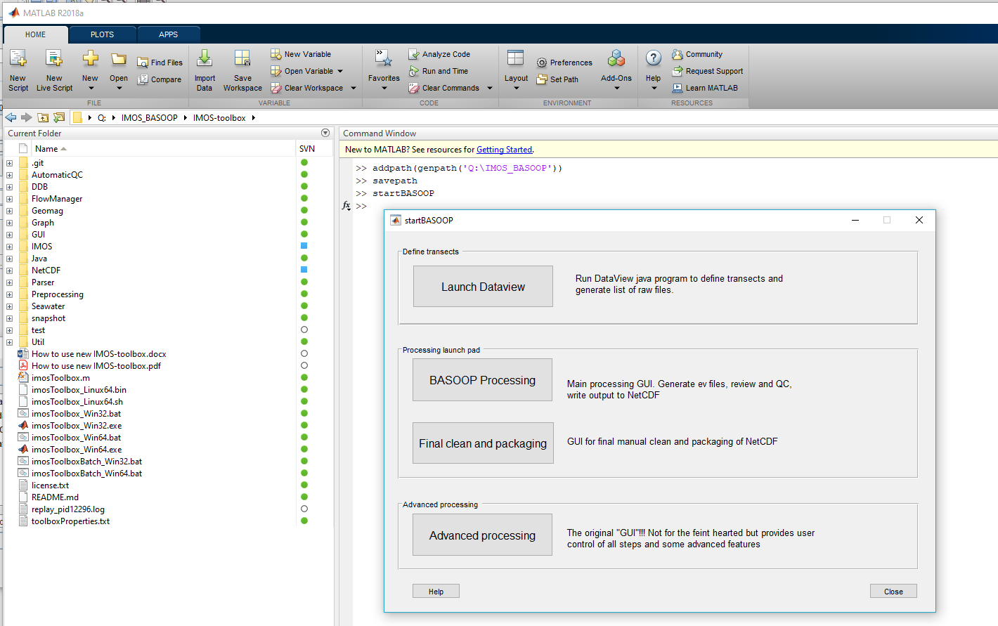

Figure 11. Initial Matlab view for startBASOOP GUI.

If you haven’t already run the Dataview steps you can run it from here by clicking the top button for “Launch Dataview”.

Once your data is all set up and ready for processing, click on “BASOOP Processing”. This will pop up the box below asking how to start the GUI. Last used will open the GUI with the last settings you used. It is recommended to always use ‘Defaults ([])’, because sometimes settings can be carried over from previous sessions that you aren’t aware of. **Only use Last Used if you are sure of the settings used or are picking up from where you left off.**

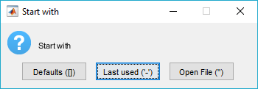

Figure 12. GUI start-up parameters.

The default GUI window should look like this:

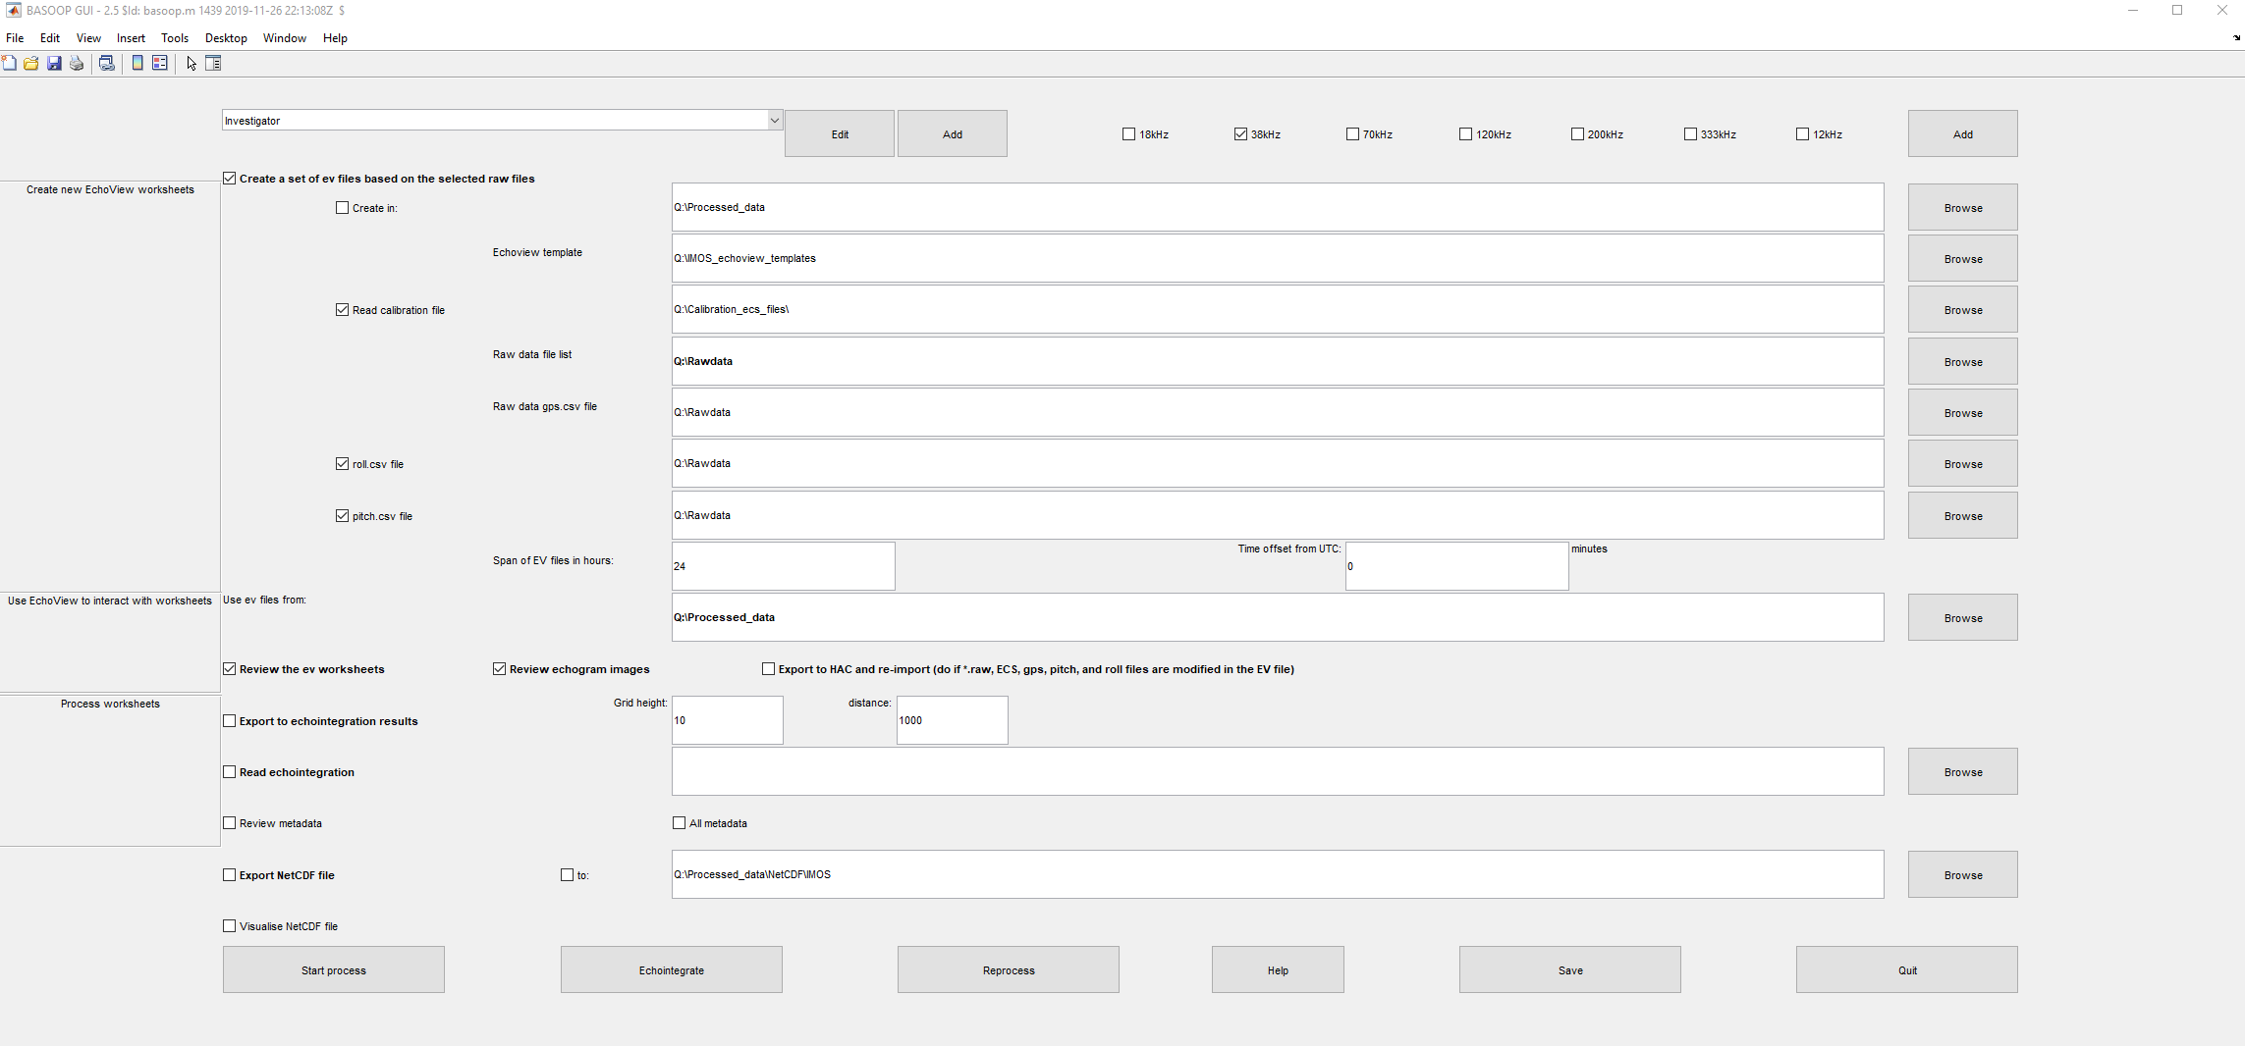

Figure 13. GUI default interface.

Important nuances to note: Any box that is checked will get executed when you hit Start Process. Usually, the steps are run in a series, so you can check the results along the way and break up the process, but make sure you uncheck things you aren’t currently working on, otherwise, they will be run anyway. It is nearly impossible to kill the GUI or processes running once they start (even the good old CTRL+c in the Matlab command window won’t stop it) so if something is incorrect you will just need to wait for it to finish.

### Step 1: Creating new EV files

From the drop-down box in the top left corner, choose the appropriate vessel (Investigator).

To the right of this, check the boxes for the frequencies to process, which are usually 18 kHz, 38kHz, 70kHz, and 120 kHz (NOTE! By default, 38kHz is checked, so make sure to check relevant boxes before you start processing!).

Check the box for “Create a set of EV files based on the selected raw files”

**Echoview template**: Browse to the template file to use. An example is given below.

Q:\IMOS_echoview_templates\IMOS_BASOOP_template_Ex60\Ex60_V1.28.ev

**Check Read Calibration file**. For example, use the ECS file as shown below.

Q:\Calibration_ecs_files\Investigator\Global_ECS_files\EK60\

**Raw data file list**: Browse to the ‘*_datalist.txt file’ in your raw data folder for the transect you will be processing (created in Basoop.jar step 2.2.3).

**Raw data gps.csv file**: Browse to the gps.csv file for your data range (created in Basoop.jar step 2.2.3).

**Roll.csv file**: Browse to roll.csv file created in (created in Basoop.jar step 2.2.3).

**Pitch.csv**: Browse to pitch.csv file created in (created in Basoop.jar step 2.2.3).

**Span of EV files in hours**: 24 or 48, depending on your convenience or computer performance.

The image below shows red arrows where you need to be sure to change things.

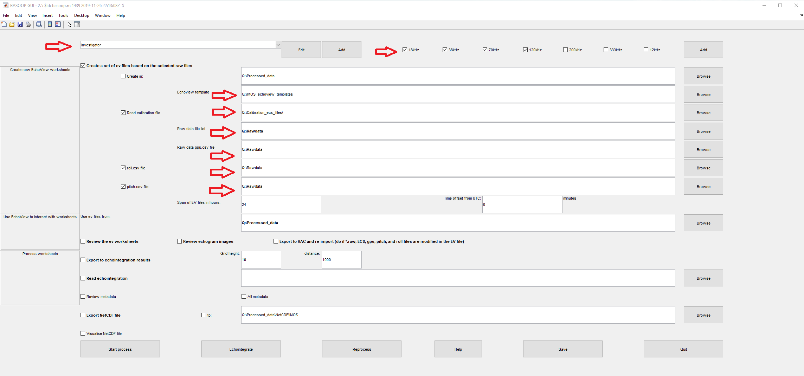

Figure 14. Red arrows indicate fields that must be filled in for initial creation of EV files.

Click “Start Process” at the bottom to start creating the EV files. If you want to process the EV files in Echoview immediately after, you can also check the box for “Review the ev worksheets”.

You will see a pop-up window about what files to create (Overwrite or New Only)- it is usually best to select New Only, unless you are sure you want to overwrite previous files. Another pop-up window will be presented to check the time offset to UTC.

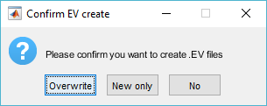

Figure 15. EV file creation confirmation.

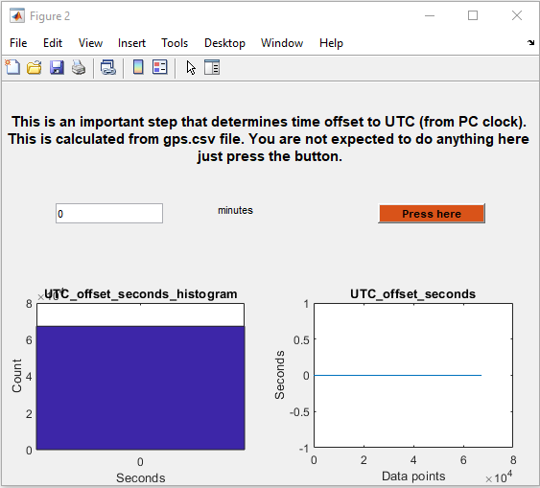

Figure 16. UTC time offset check window.

This process will set up a folder within ‘Processed_Data’ mirroring the naming you set up in ‘Rawdata’ folder, with a folder within it for the template used (Ex60_V1.28) and then a folder for the Echoview worksheets it creates.

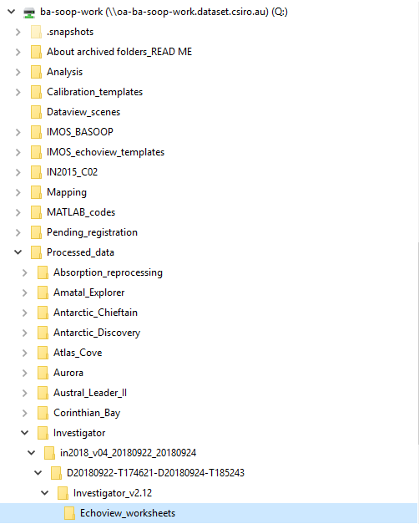

Figure 17. File structure created from GUI.

### Step 2: Review EV worksheets

If you didn’t check “Review the ev worksheets” previously, check this box. Make sure to uncheck the box for “Create a set of ev files”.

In the box to the right, browse to the ‘Echoview_worksheets’ folder created in the previous step and select the “EV-files_****.txt” file. This contains a list of the EV files created that it will ask you to review. Click “Start process” again.



Figure 18. Review Echoview worksheets step.

A window will pop-up with a list of the EV files for your transect. They are split into 48 hour segments (for example), so you will have however many 48 hour files to make up your whole transect. Highlight the file you want to review, and click Review.

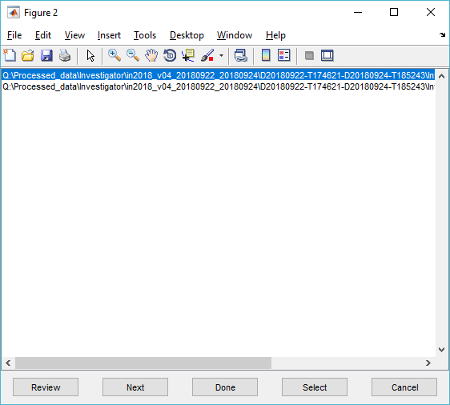

Figure 19. Review Echoview worksheets window.

This will open an instance of Echoview. Edit your file as needed in Echoview. When finished, go back to this window. To move to the next file, click “Next”- this will save your current file and open the next one in Echoview. If you are finished with everything, click “Done”, which will save the current file and exit Echoview. Or to be safe, save in Echoview as well before clicking Next or Done. For specifics on Echoview processing, see section 5.

### Step 3: Export echo-integration

After reviewing the data in Echoview, the results can be echo-integrated. Uncheck the previous boxes, and check “Export to echo-integration results”. The Grid height is 10 and distance is 1000 by default. Embedded in this step is the application of sound velocity and absorption corrections based on climatology (CARS, synTS).

Make sure at this point all the checkboxes at the top for the frequencies you want are checked! (e.g. 18kHz, 38kHz, 70kHz, and 120kHz). Only the frequencies with the box ticked will be exported.

Click “Start process”.

The echo-integration results will be output to a new ‘echointegration_output’ folder as a series of .csv files, as shown below.

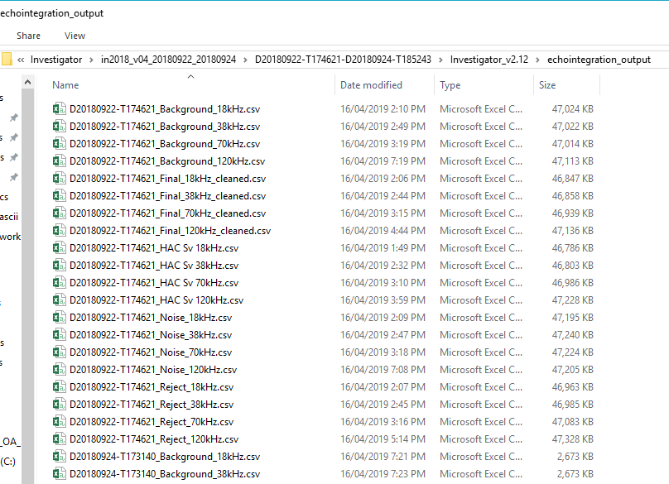

Figure 20. Echo-integration output created.

### Step 4: Packaging into NetCDF, metadata and visualisation

The final step in the process is to package up your echo-integration results with metadata into a NetCDF file that will be posted to the IMOS repository. Uncheck all previous boxes, then check “Read echo-integration”. Browse to the ‘echointegration_output’ folder that was created in the previous step.

Check the box for “Review metadata” and “All metadata”. The first box will bring up a subset of the key metadata values to fill out. All metadata will bring up a subsequent box with all possible values. Many of these will not need to be changed, but it’s good to cast an eye over these just in case as it is a pain to re-export the NetCDF with metadata changes.

Check the box for “Export NetCDF file”. Do not check the box next to “to:”. By default, it should export to the correct folder. This box just allows you to change the output folder to something else if you ever wanted to.

Check the box for “Visalise NetCDF file”. Once the NetCDF is created, number of figures will pop up showing the results. These are useful to check that the data is actually ok and will highlight any issues that you may need to go back and fix.

Click “Start process”.

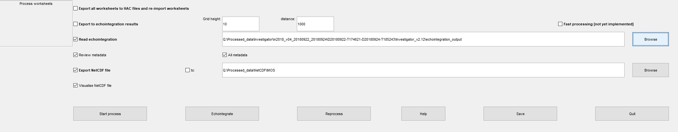

Figure 21. GUI boxes to be checked for final packaging.

A series of windows will tell you if there is metadata missing (shown below). Define appropriately.

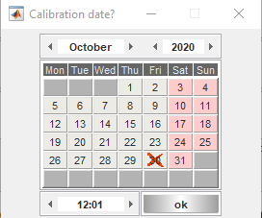

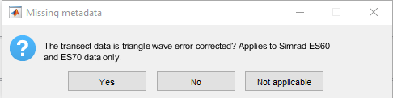

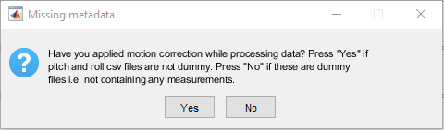

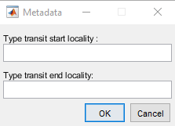

Figure 22. Initial metadata warnings.

Defined metadata can be reviewed and changed as below.

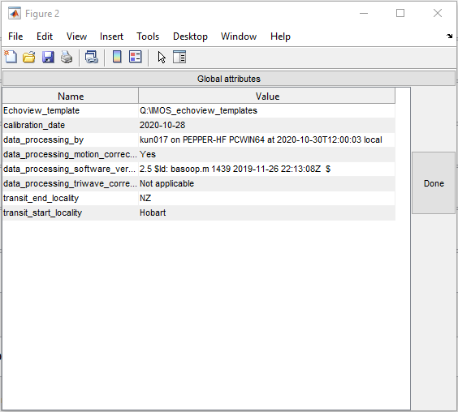

Figure 23. Pre-metadata box

As it runs through the packaging process you will see Echoview being opened and closed during various steps- just let it do its thing. The next metadata window that pops up shows more comprehensive values. Change fields as needed. The abstract and title values should have been automatically populated based on the ‘end_locality’ and ‘start_locality’ you put in previously. Check these at this point to make sure you didn’t put them the wrong way around. If so, you can change it manually here. Once all the global attributes are correct, click on the drop-down box and go to each frequency and check.

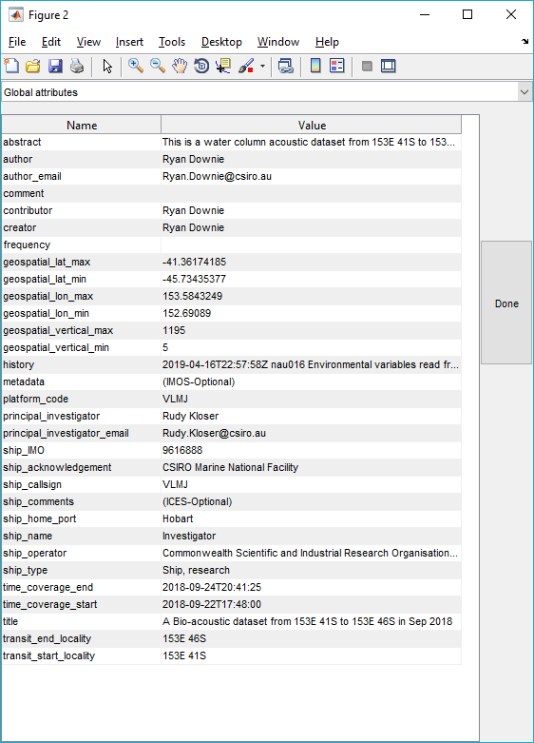

Figure 24. Review metadata- global attributes.

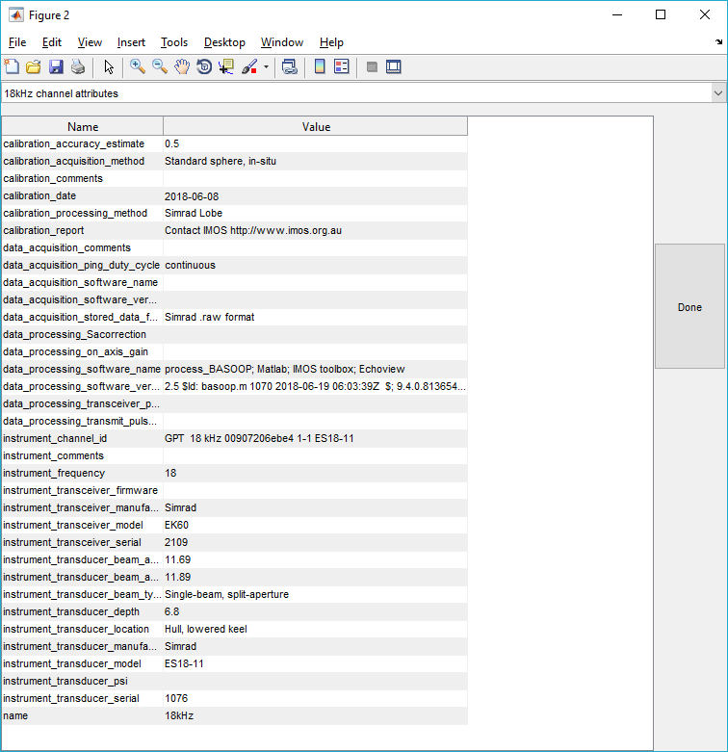

Figure 25. Review metadata- frequency specific.

You may get a pop-up about Echoview Ascii files- just click Yes to re-export. This is for viewing processed NetCDF data in Echoview. This is an optional step in the processing, done after creating the processed NetCDF.

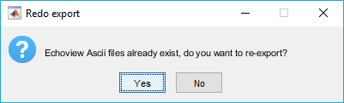

Figure 26. Echoview Ascii export

Another box will pop up reminding you about the compliance of metadata according to the convention followed - check the Matlab command window progress message to see if there are any missing global attributes or variables.

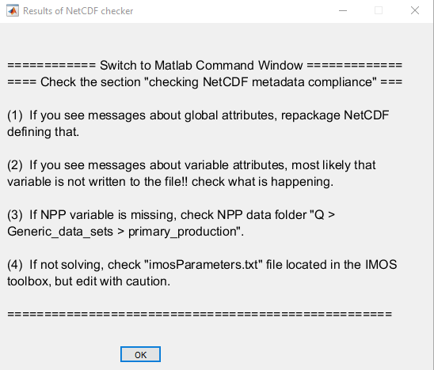

Figure 27. Metadata compliance check message box.

The visualise step will then pop up many figures to review your data.

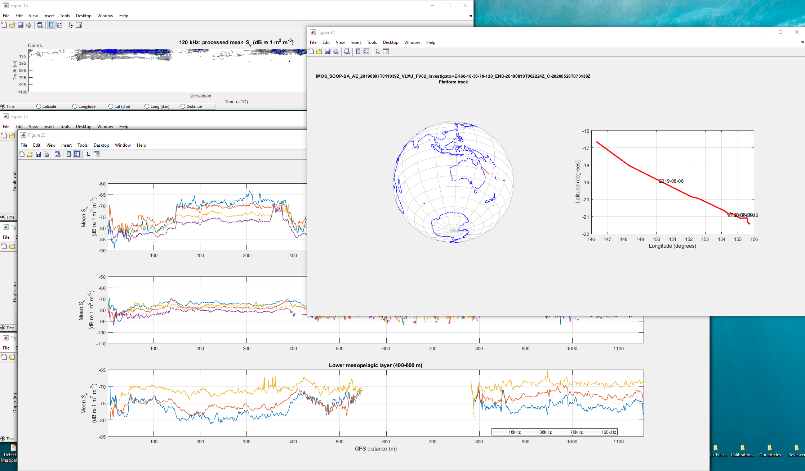

Figure 28. Visualise NetCDF.

Your final NetCDF will have been created in the Ex60_V1.28 folder of your processed data, as below.

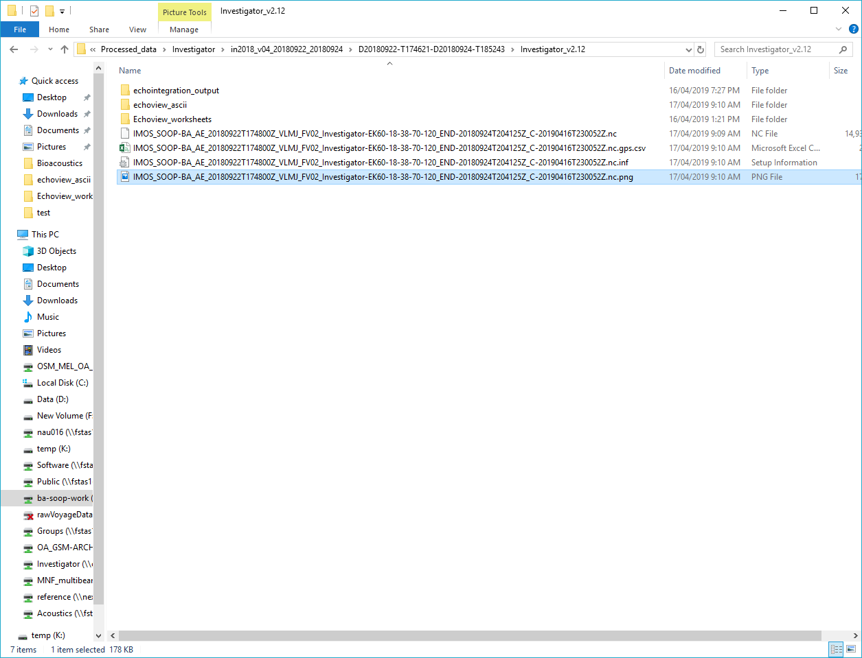

Figure 29. Final NetCDF file location.

# Echoview Processing

### Echoview overview of things to check

1. If needed, edit the bottom track line while scrolling through- make sure there are no gaps
2. Check lower line- drop below biological features (discrete) that might be removed by transient noise and spike filter
3. Manually edit noise OR preserve features from filters by creating regions
   1. e.g. second bottom- select with polygon and set region as bad data (no data) Unclassified
   2. Areas of very high attenuation (e.g. lots of dropped pings due to bad weather)- block out whole region as bad data (no data) using the Vertical Band tool
   3. Block out whole sections on station (CTDs etc) using the Vertical Band tool

### Echoview helpful hotkeys

f: Scroll forward in echogram

r: Scroll backward

w: Zoom out

s: Zoom in

m: Create region (once you have an area selected)

l: applies line edits

### Navigating the dataflow

When Echoview opens, you should see the very complicated Dataflow. To process the data, each frequency needs to be edited separately. To check the raw data, open the “Sv_18kHz” (or frequency of interest). You can open variables down the chain to see how they are being applied at each step. The final processed version is the “Reject_18kHz” variable. When processing, I generally have the raw (Sv_18kHz), Final_18kHz_cleaned and Reject_18kHz all open at once and synchronised. Scroll through the data and create regions as needed to block out raw data. Make sure that these edits are seen coming through to the final version (Reject_18kHz).

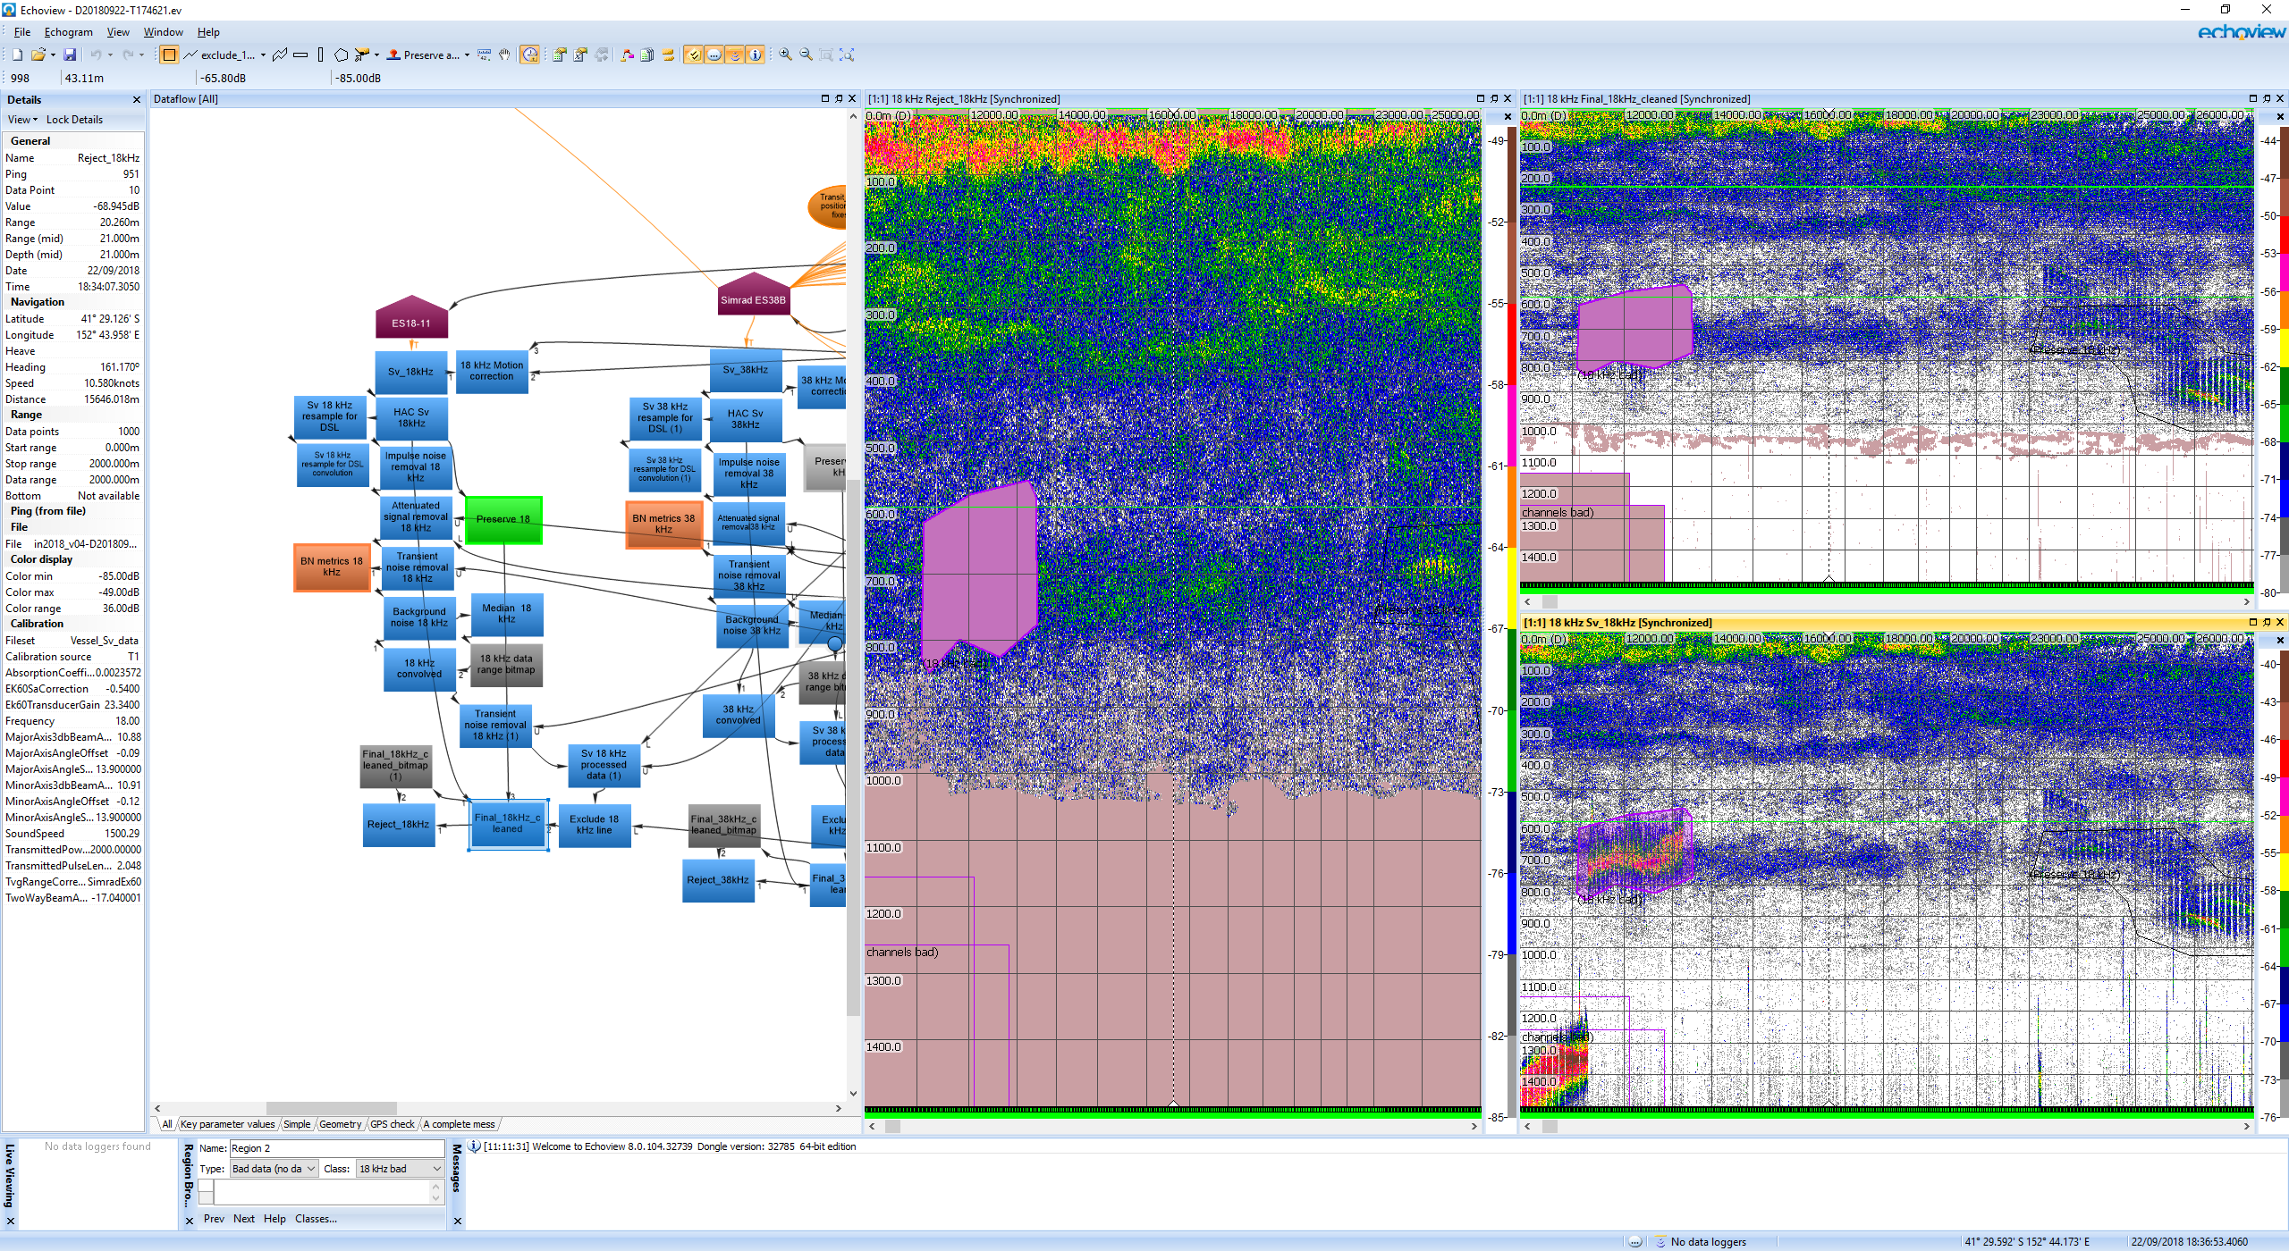

Figure 30. Echoview Dataflow and processing setup.

### Regions

To block out areas of bad data, use one of the shape tools to draw a box or polygon around the area. Right click and choose Define Region (or press m).



Figure 31. Tool options for creating polygons.

In the Region Browser window (shown below), change the Type: to Bad data (no data). Change the Class to the frequency you are editing (e.g. 18kHz bad). If you want to make the region bad data for all frequencies, choose “all channels bad”. If there is data that is being removed by a filter, but it is actually good data you want to preserve, change the Type to Analysis and the Class to Preserve 18kHz. If you use this, make sure to check the final exports carefully to make sure the data is being handled as expected.

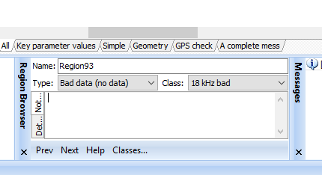

Figure 32. Region Browser window- make sure to change these values each time a region is created.

### Acoustic bottom

For areas <1500m, make sure that the acoustic bottom is correctly picked. This can be either manually edited or repacked with a backstep value. The key is to make sure there are definitely NO bottom picks still included in the data for echo-integration. Any bottom value will highly skew the biological values. It is better to remove more area close to the seabed if in doubt.

### Lower line

The lower line is used by the Transient noise filter. Data above this line are not touched by the filter because the high backscatter values in the upper water column are generally due to real biology. The filter is only applied to data below this line. Occasionally, the actual biological layers will be below this line, and you will start seeing particularly high backscatter areas being removed by the filter. To prevent these real features from being removed, edit the lower line to place it below the biological scattering layer or feature, as shown below. You should then see these features are no longer removed by the filter.

